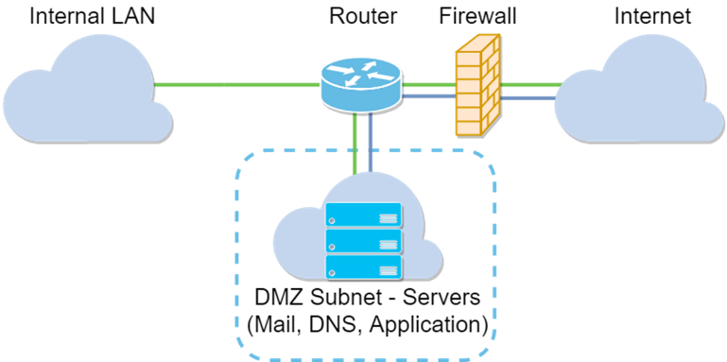**The Structure of the Metropolis Transit company.**

Educating The Employees

CISO-

* Create Password Policy
* Update HR Policy
* Cloud Policy
* SETA Policy

Ticket buying process, by ensuring that the data is transmitted encrypted

Cloud Policy

Backup

C-Level

CIO -Update the Operational Management Policy

Password Sharing

Source Code Review

NTP

* SIEM
* AD
* FS
* Patching
* ITAM
* Change Management
* Whitelisting

Network infrastructure

Data Handling

Operational Management Policy

IT Team

Why Those Policies

1. Employment process
2. Transfer/Disciplinary process
3. Access Review

HR policy

Human Resource Team

It contains the services that support the corporation operations

Monitor the traffic

The Goal of all of it aims to the tone of the organization which is to provide a safe environment as specified in the Enterprise policy.

That houses the services